## E-Portfolio Website:

<https://nlz-crtl.github.io/nlz-ctrl.io/>

## Branch for research methods:

# Reflection: "Research Methods and Professional Practice" 2nd attempt

Reflecting on my journey through the module "Research Methods and Professional Practice" I delve into the activities and key learnings that have shaped my academic and professional development. This reflective essay aims to not only describe the challenges encountered but also critically discuss the implications of these experiences, particularly within the realm of cybersecurity.

As a student navigating the complexities of the Research Methods course, I was met with challenges that spanned from time constraints and workload management to concerns about the practical relevance of the content for my chosen career path in cybersecurity. This journey was marked by both emotional highs and lows, ultimately contributing to a deeper understanding of the research process and statistical analysis techniques.

Time constraints and workload emerged as formidable adversaries during the course, as balance between work obligations and coursework proved challenging. The demanding workload often left me feeling overwhelmed, hindering my ability to delve deeper into the subject matter. The main learning I take away from this is to implement better time management techniques. A key finding from Alvarez, Ferrero & Ugidos (2019) is that not the amount of time available but the management that is made of it is the decisive factor. They argue that the correct use of time and the development of skills such as self-organisation, prioritisation of objectives and activities are skills that can be learned and put into practice. This means for me that I will develop an action plan to actively learn, improve and implement time management skills to improve my academic performance.

The extensive reading list, dominated by theoretical materials, presented a disconnect between the academic content and the practical applications. This raised questions about the efficacy of the curriculum in preparing individuals for real-world challenges in cybersecurity.

In a field as dynamic as cybersecurity, the theoretical foundation alone may prove insufficient to navigate the evolving landscape effectively.

In terms of practical value for a career in cybersecurity, I observed a noticeable gap between the course content and the skills needed for success in my chosen field. The emphasis on research methodologies and statistical techniques, while valuable in an academic context, lacked direct applications to the challenges faced in cybersecurity roles. The takeaway from this experience is for me the conclusion that I learn better with practical examples. Hence, going forward I will actively try to relate the concepts learned in the course to real-world situations and challenges. I regularly face scenarios in my work as an IT-consultant in which some of the course content could be applied. In the future I will make an active effort to relate the theoretical concepts to my real-life experiences in order to improve my experience as a student of research methods.

Another challenge I encountered was the realisation that the Research Methods course was designed primarily for students pursuing a master's degree. While I appreciate the importance of research methods in academia, I do not plan to pursue further graduate studies. This misalignment made me question the relevance of certain coursework to my immediate career goals. In hindsight I should have checked the demands of the research methods course more thoroughly in order to determine if this course and the pursuit of a postgraduate degree is in alignment with my goals. While I can appreciate the academic challenges, my motivation for the completion of a masters degree suffered.

Emotionally, the course took me on a rollercoaster ride. Initial excitement about developing statistical analysis skills was tempered by the constant struggle to balance coursework with work obligations. Feelings of frustration and inadequacy surfaced as I grappled with the demands of the course.

Despite the challenges, the course did provide valuable insights into the research process and statistical analysis techniques. I developed a critical mindset, recognizing the importance of methodological rigor when approaching data. The course reinforced the significance of interpreting data accurately and drawing meaningful insights. While the practical experiences I desired were lacking, the strong theoretical foundation gained during the course forms a solid basis for future endeavors.

Group discussions emerged as a highlight of the course, offering a positive and collaborative learning environment. Engaging with peers and exchanging ideas allowed me to gain diverse perspectives, contributing to a more enriching educational experience. Especially the group discussion about “Codes of Ethics and Professional Conduct” provided me with valuable insights. The responses from my peers were all very beneficial and added to the overall discussion.

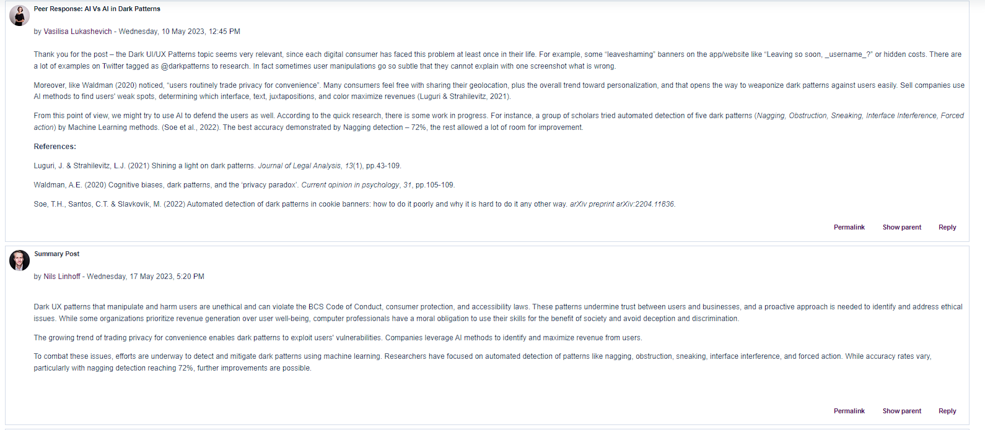

*Figure 1:* Screenshot of the collaborative discussion 1.

I realised that I prefer this style of learning and as Lake (2001) states, group discussion can improve students performance over theoretical lectures. As an outcome from the experience I will try to implement group discussions or discuss the lecture topics with my peers whenever possible. I am certain this will provide a valuable exchange between students and can deepen the understanding of the material. A discussion forum or an exchange outside of the constraints of the course can help to facilitate this. I can plan the next steps in my action plan in order to enhance my academic and professional development.

In conclusion, the Research Methods course was a multifaceted experience that presented both challenges and opportunities for growth. While providing valuable insights into statistical analysis and research methodologies, it also highlighted the need for critical discussions surrounding course design, practical relevance, and emotional well-being. As I navigate my future path in cybersecurity, I am determined to seek out opportunities for practical learning and hands-on experiences that align with my career goals. In this reflection I have identified several learnings and outcomes which I can put into an action plan in order to further my professional development.

Word count: 960

## Bibliography

Alvarez Sainz, M., Ferrero, A.M. and Ugidos, A. (2019) ‘Time management: skills to learn and put into practice’, *Education + Training*, 61(5), pp. 635–648. Available at:<https://doi.org/10.1108/ET-01-2018-0027>. (Accessed: January 8, 2024).

Lake, D.A. (2001) ‘Student Performance and Perceptions of a Lecture-based Course Compared With the Same Course Utilizing Group Discussion’, *Physical Therapy*, 81(3), pp. 896–902. Available at:<https://doi.org/10.1093/ptj/81.3.896>. (Accessed: January 8, 2024).